OVERVIEW:
This document provides cleanup options for Azure resources in the EMT DevTest subscription. Each section identifies specific resource types that can be safely removed to optimize costs and perform cleanups.
CLEANUP CATEGORIES:
- APPSERVICE PLANS WITH NO APPS
- Purpose: Identifies empty App Service Plans with no hosted applications
- Criteria: properties.numberOfSites == 0
- Cost Impact: App Service Plans incur charges even when empty
- Cleanup Action: Delete unused plans or consolidate apps into existing plans
- Risk Level: LOW - No impact on running applications
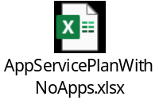
- EMPTY RESOURCE GROUPS
- Purpose: Finds resource groups containing no resources
- Criteria: Resource groups with null resource count
- Cost Impact: NONE - Resource groups are free. Stright forward to clean up
- Cleanup Action: Delete empty resource groups to reduce clutter
- Risk Level: NONE - No resources affected
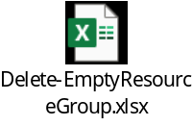
- EMPTY SUBNETS
- Purpose: Identifies unused subnets in virtual networks
- Criteria: No IP configurations, delegations, or application gateway configurations
- Cost Impact: NONE - Subnets are free but consume IP address space
- Cleanup Action: Remove unused subnets to optimize network design
- Risk Level: LOW - Verify no future deployment plans
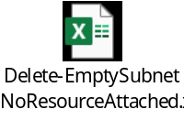
- UNATTACHED DISKS
- Purpose: Finds orphaned managed disks (90+ days old)
- Criteria: Not managed by any VM and older than 90 days
- Cost Impact: Disks incur storage charges continuously
- Cleanup Action: Delete after verifying no backup/recovery needs
- Risk Level: MEDIUM - Ensure disks don't contain critical data
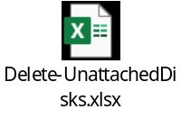
- UNATTACHED NETWORK INTERFACES
- Purpose: Identifies unused network interfaces
- Criteria: Not attached to VMs, private endpoints, or link services
- Cost Impact: Minimal charges but consume IP addresses
- Cleanup Action: Delete unused NICs to free IP addresses
- Risk Level: LOW - Verify not reserved for specific purposes
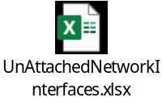
- UNATTACHED NETWORK SECURITY GROUPS
- Purpose: Finds NSGs not associated with any resources
- Criteria: Null network interfaces and subnets properties
- Cost Impact: NONE - NSGs are free but create management overhead
- Cleanup Action: Delete unused NSGs
- Risk Level: LOW - Verify not part of known creations/ deployments
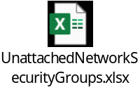

- RESOURCE – ACTIVITY LOG
- Purpose: Analyzes last access patterns for all subscription resources
- Method: Queries Azure Activity Log excluding Microsoft.Advisor events
- Output: Comprehensive resource list with activity timestamps and API events
- Usage: Provides data-driven insights for cleanup impact assessment
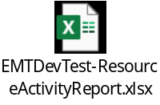

RECOMMENDED CLEANUP SEQUENCE:
- Start with Empty Resource Groups (zero risk)
- Remove Unattached Disks older than 90 days (cost savings)
- Clean up Empty App Service Plans (cost savings)
- Remove Unattached Network components (low risk)
- Use Activity Log data to identify inactive resources for broader cleanup
- Consolidate remaining relevant resources into logical resource groups

PRECAUTIONS:
- Check with resource owners before deletion
- Take snapshots of critical disks before deletion
- Review activity logs for resources inactive >90 days
- For retained resources, plan logical resource group structure before moving to it
- Ensure proper tagging strategy for moved/ retained resources in EMT Dev Test subscription

